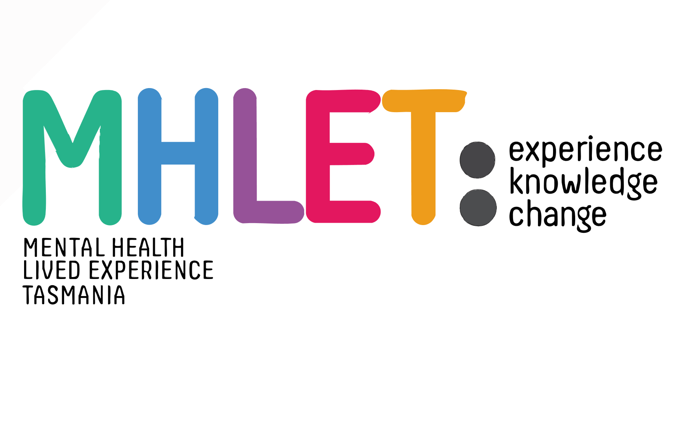

**Ways of Working Safety Policy**

At MHLET we are committed to ensuring safety and respect in all our interactions and aim to create inclusive spaces where everyone feels safe, valued, and heard. We follow principles and practices that ensure that every interaction promotes trust, collaboration, and well-being. Together, we aim to create meaningful change.

MHLET values safety, trust, and inclusivity in everything we do. Staff and members apply these principles in the following ways:

1. **Safety and Trust**: We prioritise emotional, physical, and environmental safety for all. Our ways of working ensure transparency and sensitivity in all operations.
2. **Choice, Collaboration, and Connection**: Members have opportunities to choose their level of involvement. We promote collaboration and meaningful connections through respectful engagement.
3. **Accessibility and Inclusion**: Our operations support the diverse strengths and perspectives of members and staff. We celebrate inclusivity and ensure everyone feels valued. Feedback is welcomed and strongly considered.

MHLET staff and members commit to practices that:

* Prioritise emotional and physical safety of all individuals.
* Value contributions from those with lived/living experiences.
* Adhere to strict confidentiality practices.
* Encourage respectful communication and listening.
* Promote inclusivity and respect diverse backgrounds.
* Address any barriers that hinder participation.
* Respect individuals’ choices to opt-in or opt-out during discussions.
* Provide clarity and address concerns promptly.

***Note****: This document should be read in conjunction with the following additional MHLET resources:*

* **Sharing Lived Experience**: Respectfully and safely for sharing lived experiences.
* **Conflict Resolution**: Approaching disagreements with respect for diverse viewpoints.
* **Ways of Working Checklist**: MHLET’s commitment to safety at every engagement.

**By signing below, you state that you have read the documents as listed and agree to ways of working that are consistent with the principles and practices outlined in this document.**

**Print Name:_________________________________________________________________________**

**Signed:__________________________________________________ Date:______________________**



**MHLET guide for Sharing Lived Experiences**

Sharing lived/living experiences can be deeply personal and vulnerable. As an organisation, MHLET holds the responsibility to ensure that both the vulnerability and benefits of sharing one’s story are held with care and consideration. We seek to foster an environment where individuals are safe to share without fear of judgment or exploitation and we draw upon the following practices to do so:

**Confidentiality and informed consent**

Prior to sharing stories, we:

* Review confidentiality and informed consent. We review what stays in the space, and what can leave the space. We ensure it is understood that stories shared do not get shared without explicit permission, even in ways that are ‘de-identified’.
* Discuss the potential impacts of sharing stories and personal experiences, ensuring that storytellers can make an informed decisions about what and how they choose to share.

**Trauma-aware**

In recognising the potential for storytelling to evoke association and resonance for listeners, we adopt trauma aware approach. This involves acknowledging the possibility of triggering experiences while actively working to minimise harm through encouraging:

* Individuals sharing their stories to identify potential content triggers for listeners, allowing for preparation and informed consent for listeners to make choices about their participation.
* Listeners to ‘take a break’ when or if its needed and seek support.

**Supportive Listening**

Sharing stories safely requires environments to be non-judgmental. We encourage:

* Empathetic, validating, and respectful listening, free from judgment or criticism.
* Listeners to bring forward support and understanding and support an environment of sharing where individuals can feel seen, heard, and valued.

**Resources and Support Services**

We recognise that sharing lived experiences can evoke a range of emotions and responses, and as such, we ensure that information about accessing support services and resources is accessible to the space. This includes:

* providing access to information about counselling services, support groups, helplines, and other resources that individuals can access before, during, and after hearing or sharing stories.



**MHLET Guide for Approaching Conflict Resolution Safely**

Working together safely requires effective conflict management and resolution when it arises. The goal with conflicting perspectives is to reach resolution that respects views of all parties involved. All participants should feel heard and valued and be able to contribute to a culture of empathy and understanding.

People consulted because of their lived experiences offer different perspectives and opinions. We approach discussions with an understanding that diverse views are expected and acknowledge the individuality and intersectionality of lived experience.

All discussions will be moderated by a facilitator; however, all participants have an individual responsibility to identify any potential conflicts and work to resolve them using the following strategies:

* 1. **De-personalise the conflict.**

Instead of attributing the issue to individuals, focus on the problem itself. For instance, if there's a disagreement over the direction of a project, refrain from stating "you're wrong," and instead offer an intention to “hear the different perspectives on the issue."

* 1. **Avoid personal attacks.**

Maintaining a respectful and productive environment is crucial. When passions run high, a difference of opinion can be misinterpreted as a personal attack. Pause to consider if this is the case, take a step back, and remind yourself and others to keep the discussion focused on the problem.

* 1. **Acknowledge the other side (s)**

Actively listen to the opposing, or different viewpoint and practice paraphrasing what the other person is saying to show understanding and validate their perspective. For instance, "I understand that you're concerned about the timeline, and I appreciate your attention to detail.". Opposing viewpoints provide us an opportunity to gain a new perspective.

* 1. **Find common ground.**

When opposing opinions refuse to compromise, nothing moves forward. Instead, work towards a resolution that benefits everyone involved. You might say, "Let's see if we can find a solution that addresses both of our concerns."

* 1. **Pursue an outcome centred on understanding.**

Instead of focusing on ‘winning the argument’, prioritise mutual understanding. Encourage open dialogue where others can express their thoughts and feelings without fear of judgment. This could involve asking open-ended questions like, "can you help me understand your perspective better?"



**Ways of Working Checklist**

Following opt-in processes, and prior to engagement:

|  |  |  |
| --- | --- | --- |
| **Pre-engagement:** | | |
| 1. | Participants have been provided clear information about the events’ details, including location and address |  |
| 2. | Transparency about the purpose, expectations and confidentiality of the engagement |  |
| 2. | Participants provided with an introduction to key staff, contacts, and attendees |  |
| 3. | Access to relevant documents ahead of time |  |
| 4. | Ensure venue is accessible to all, with adequate resources |  |
| –5. | Inform of withdrawal processes |  |
| 6. | Participants provided with *Ways of Working Safety Policy* |  |
| **Engagement** | | |
| 1. | MHLET has created a warm and welcoming environment for participants |  |
| 2. | MHLET has ensured the availability of at least one (1) support person. Larger groups may require more support persons |  |
| 3. | Participants have been welcomed and oriented |  |
|  | Participants reminded of MHLET’s *Ways of Working* principles |  |
| 4. | Housekeeping instructions provided, including:   * Break schedule * Locations of facilities |  |
| 5. | Safety procedures/processes provided, including:   * Emergency procedures * Support processes (e.g. thumbs-up/down) |  |
| 6. | Reviewed confidentiality and informed consent |  |
| 7. | Addressed any barriers that hinder participation |  |
| 8. | Encouraged respectful communication and listening |  |
| 9. | Promoted inclusivity and respected diverse backgrounds |  |
| 10. | Maintained emotional and physical safety for all participants |  |
| 11. | Providing clarity and addressing concerns promptly |  |
| 12 | Provided opportunity for participants to ask questions |  |
| 13. | Provided Resources sheet with information on appropriate supports and resources that individuals can access post-engagement |  |
| **Post-engagement** | | |
| 1. | Provide any required follow-up with participants |  |
| 2. | Send any requested information and/or resources to participants |  |